Stacey Napier PDA Evidence

I.T 1 - Encapsulation

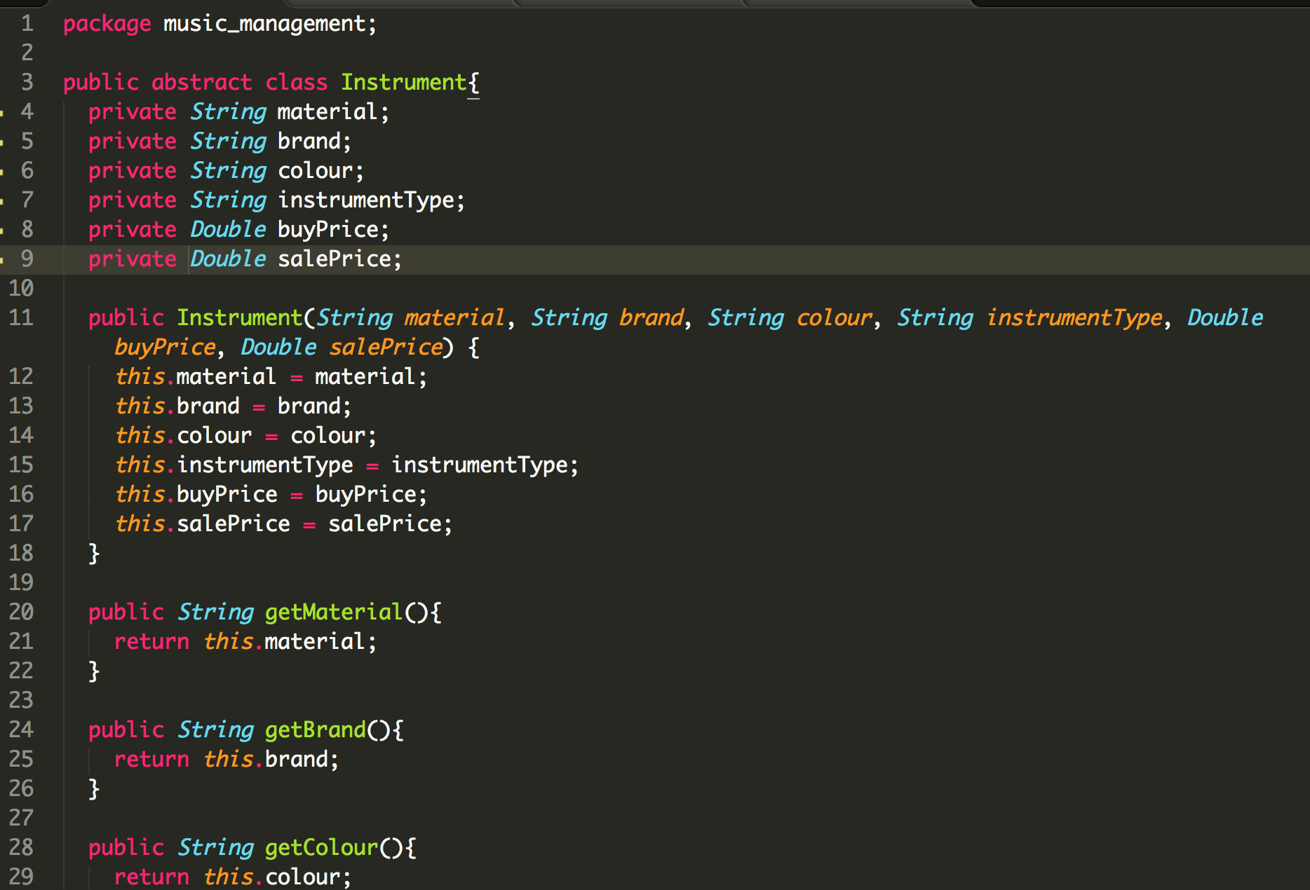

I.T 2 - Use of inheritance

* A Class



- A class that inherits from the previous class

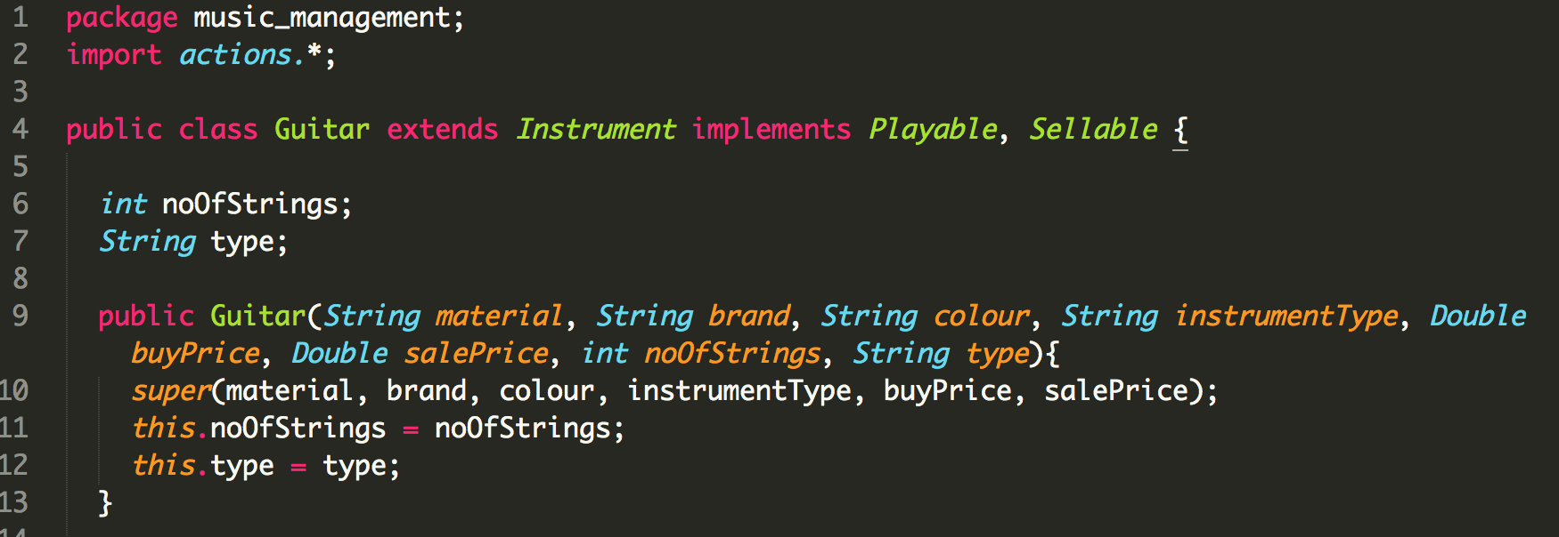- An object of the inherited class

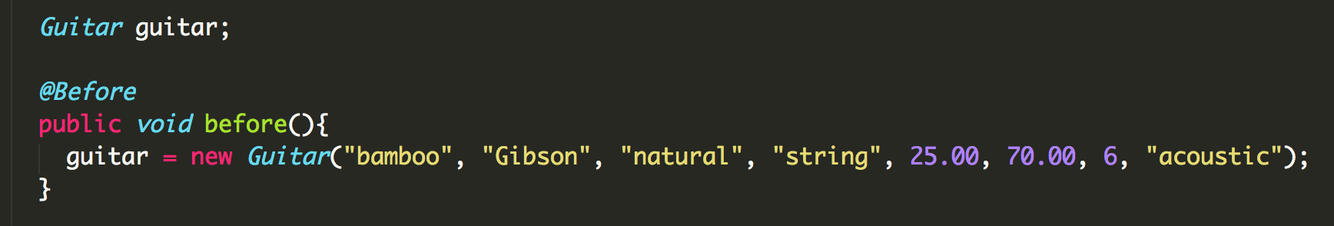 - A method that uses the information inherited from another class

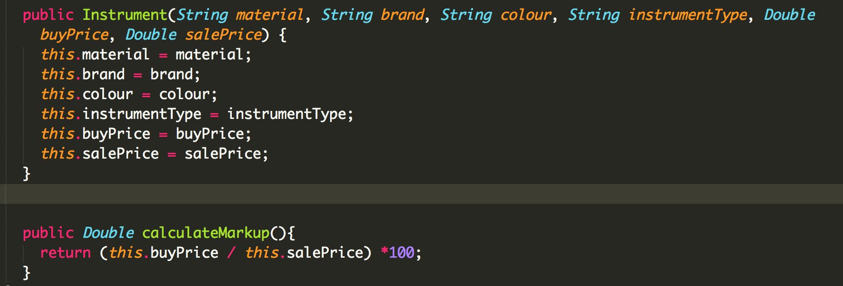

I.T 3

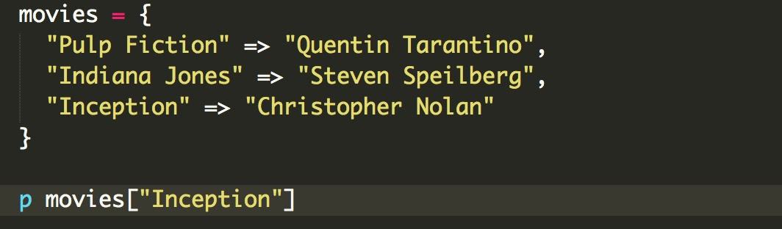

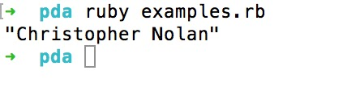

I.T 4



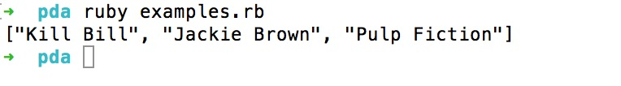

I.T 5

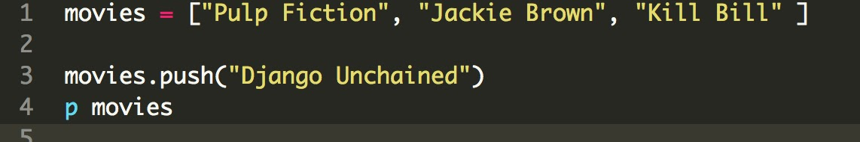

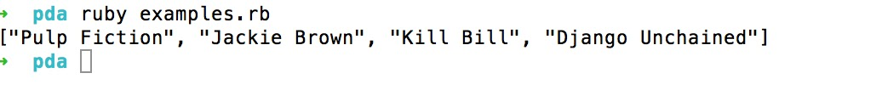

I.T 6

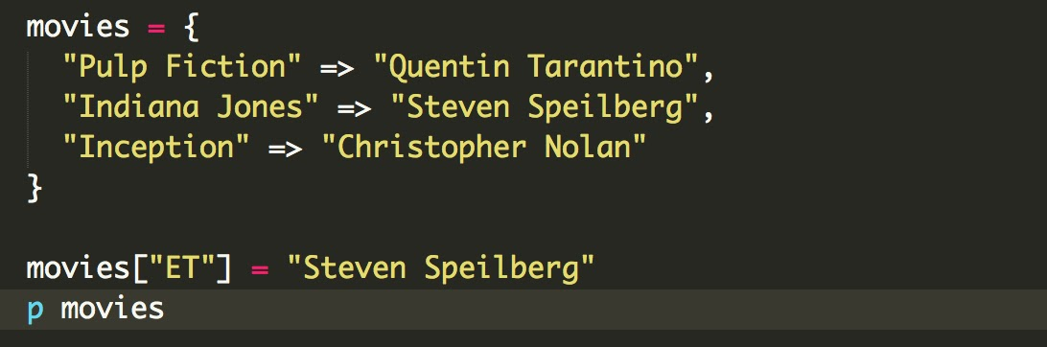

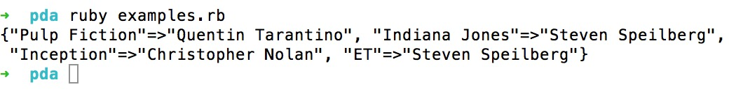

IT 7 Polymorphism

